Johnathan Soto

Professor Ravikumar

CS 315

Lab #1

1. The program halts when the numbers are in between: 1, 4, 7, 10, 13, 16,… for any number >= 0 and also halts with 0. Else if number are listed as above then output works.

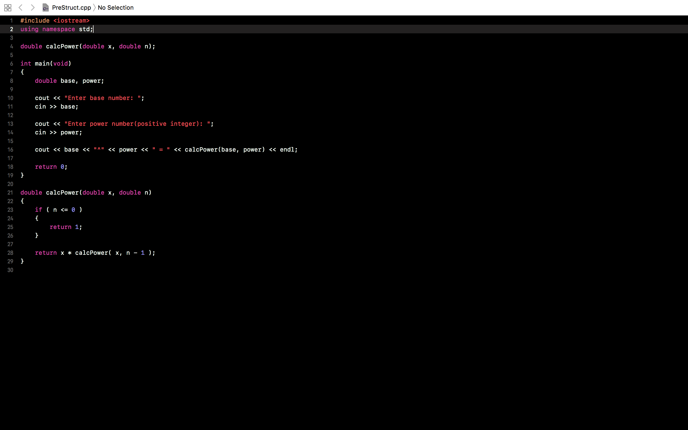

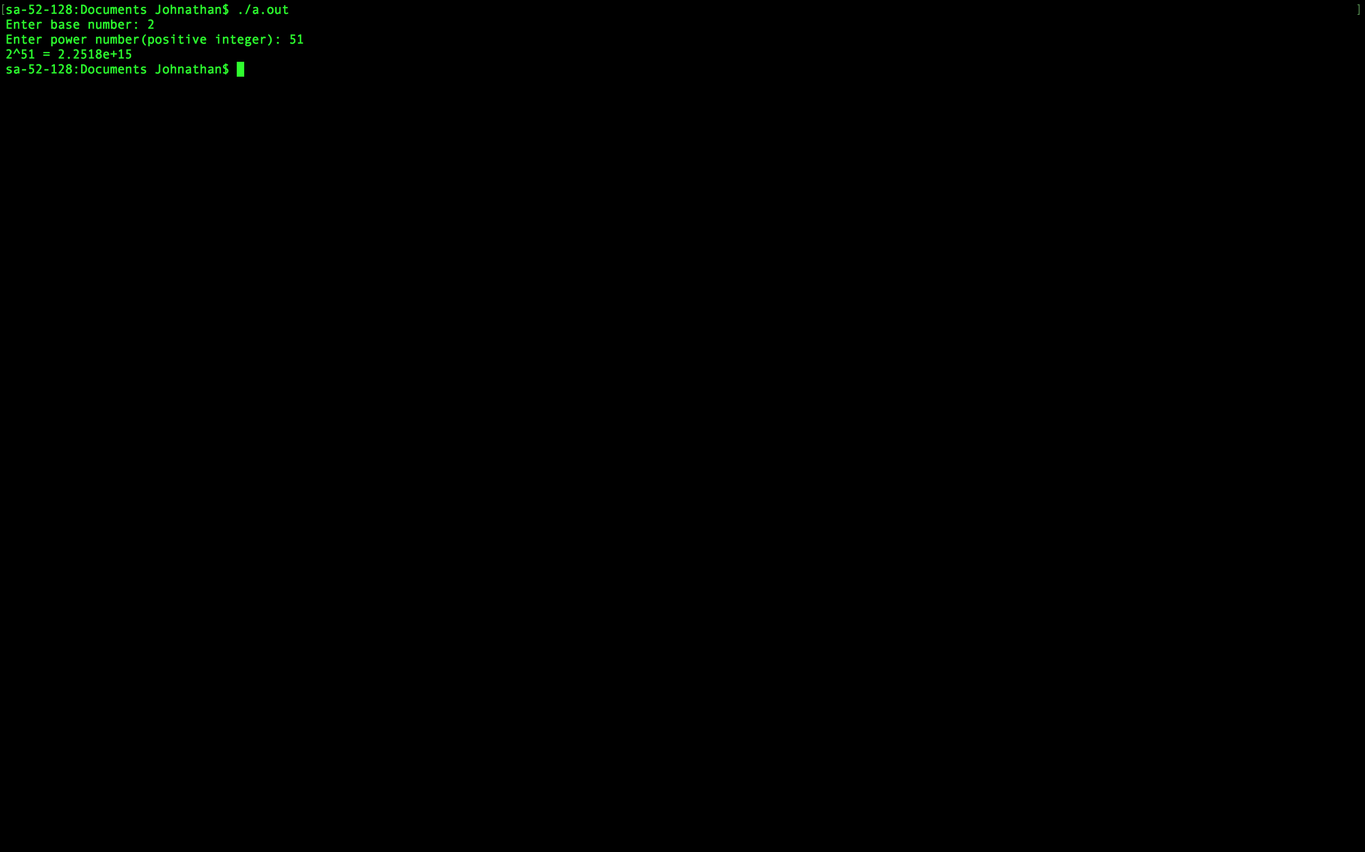

1. f(1000): 14

f(2^K): K, K being any real number

f([2^K] - 1): K + (K-2), K being any real number

1. One of the redundancies is that function call are repeated that have already been calculated such as F(1). In regards to how many times is a call to F(1) will be made when computing F(10), the answer is F(1) is called 55 times when computing F(10).

5)

